
SRM Institute of Science and Technology
SET-B
College of Engineering and Technology
DEPARTMENT OF ECE
SRM Nagar, Kattankulathur – 603203, Chengalpattu District, Tamilnadu
Academic Year: 2022-2023 (ODD)
Test: CLAT-2 Date: 17/10/22
Course Code & Title: 18ECC204J-Digital Signal Processing Duration: 8.00-9.40am
Year & Sem: III /VI Max. Marks: 50

Course Articulation Matrix: (to be placed)
 | 18ECC204J – Digital Signal Processing | Program Outcomes (POs)
 | 18ECC204J – Digital Signal Processing | Graduate Attributes |  |  |  |  |  |  |  |  |  |  |  | PSO
S. No. | Course Outcomes (COs) | 1 | 2 | 3 | 4 | 5 | 6 | 7 | 8 | 9 | 10 | 11 | 12 | 1 | 2 | 3
1 | Summarize the concepts of A//D and D/A converters. | 3 | - | - | 1 | - | - | - | - | - | - | - | - | - | - | 2
2 | Explain the concepts of DFT with its efficient computation by using FFT algorithm. | - | 2 | - | - | - | - | - | - | - | - | - | - | - | 1
3 | Develop FIR filters using several methods | - | 2 | 3 | - | - | - | - | - | - | - | - | - | - | - | 3
4 | Construct IIR filters using several methods | - |  | 3 | - | - | - | - | - | - | - | - | - | - | - | 3
5 | Discuss the basics of multirate DSP and its applications. | - | 2 | - | - | - | - | - | - | - | - | - | - | - | 1 | -
6 | Design digital filter and multi rate signal processing for real time signals | - | 2 | - | - | - | - | - | - | - | - | - | - | 2 | - | -

Part-B (5 x 10 marks= 50 Marks)
Answer any 5
Q. No | Question | Marks | BL | CO | PO
1 | (i) Compute the circular convolution of two sequence using Concentric Circle Method x₁(n)={1,2,3,1}; x₂(n)={4,3,2,2}.  ii) The output of the DFT sequence X(k)={2,1-j,0,1+j} . Find the input sequence x(n) using direct computation  (iii )Select the value of twiddle factor W₈³  - 1  - 0.707+j0.707  - -0.707-j0.707  - -1 | 5  4  1 | 3  3  2 | 2  2  2 | 2  2  1
2 | i) x(n)= {0.5,0.5,0.5,0.5,0,0,0,0} . Compute the DFT of the sequence using the inplace radix 2 DIF-FFT algorithm.  (ii)The number of multiplications and additions required for calculation of DFT using direct computation for 64 point sequence is  - 4096,4032  - 4032,4096  - 4096,2016  - 4032,2048 | 9  1 | 3  1 | 2  2 | 2  1
3 | i) X(k)={7,-0.7070-j0.7070,-j,  0.7070-j0.7070,1, 0.7070+j0.7070,j,  - 0.7070+j0.7070}. Determine the original sequence x(n) using DIT-FFT algorithm  (ii) The bit reversed order of the given sequence {1,2,3,4,4,3,2,1} is ___________  - {1,3,2,4,4,2,3,1}  - {1,4,3,2,2,3,4,1}  - {4,3,2,1,4,3,2,1}  - {4,1,2,3,3,2,1,4} | 9  1 | 3  2 | 2  2 | 2  1
4 | - (i) Design FIR filter for the frequency response=11 using fourier series method.  H_{d} (e^{jw})= { 1 for , π/4 ≤│ꙍ│≤3π/4,  = 0 otherwise  Also ,Obtain the realizable transfer function.  (ii) To reduce the frequency response oscillations, the Fourier coefficients are modified by multiplying the infinite impulse response with a finite weighing sequence is called  a. Frequency sampling Technique  b. Fourier series method  c. Windowing Technique  d. Multiplication and Truncation | 9  1 | 3  1 | 3  3 | 3  1
5 | (i) Design FIR filter with a frequency response  H_{d} (e^{jw})= 1 for, -π/2 ≤│ꙍ│≤π/2,  = 0 for π/2 ≤│ꙍ│≤π.  using Hamming window with number of samples = 11. Also, find the realizable transfer function.  ii) A filter is said to be linear phase filter if the phase delay and group delay are  a) High  b) Moderate  c) Low  d) Constant | 9  1 | 3  1 | 3  3 | 3  1
6 | (i) Design an ideal High Pass Filter the frequency of  H_{d} (e^{jw})= 1 for, π/4 ≤│ꙍ│≤π  = 0 for │ꙍ│≤π/4  Using Hanning window with N=11  (ii) The main lobe width of the hamming window is  - 2π/N  - 4π/N  - 8π/N  - 12 π/N | 9  1 | 3  1 | 3  3 | 3  1
7 | i) Find the h_{d}(n) for the following frequency response  H_{d} (e^{jw})= 1 for,│ꙍ│ ≤π/3 & │ꙍ│≥2π/3,  = 0 otherwise .  (ii) Realize the system  y(n)=3/4 y(n-1)-1/8 y (n-2) +x(n)+1/3 x(n-1). using cascade form.  (iii) The _________ window function also called as raised cosine window.  - Rectangular  - Hanning  - Hamming  - Blackman | 4  5  1 | 3  3  1 | 3  2  3 | 2  3  1

Course Outcome (CO) and Bloom’s level (BL) Coverage in Questions
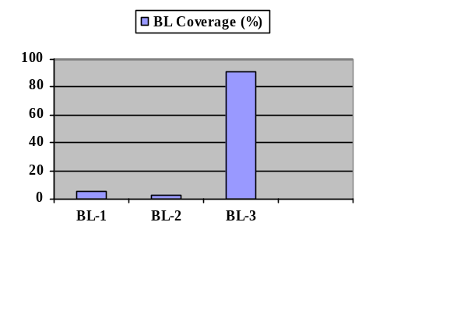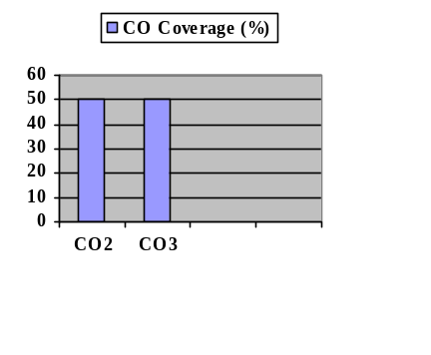
Evaluation Sheet
Name of the Student:
Register No.:

Part- A (5 x 10 mark = 50 Marks)
Q. No | CO | PO | Maximum mark | Marks obtained | Total
1 i) | 2 | 2 | 5
1 ii) | 2 | 2 | 4
1 iii) | 2 | 1 | 1
2 i) | 2 | 2 | 9
2 ii) | 2 | 1 | 1
3 i) | 2 | 2 | 9
3 ii) | 2 | 1 | 1
4 i) | 3 | 3 | 9
4 ii) | 3 | 1 | 1
5 i) | 3 | 3 | 9
5 ii) | 3 | 1 | 1
6 i) | 3 | 3 | 9
6 ii) | 3 | 1 | 1
7 i) | 3 | 2 | 4
7 ii) | 2 | 3 | 5
7 iii) | 3 | 1 | 1

Consolidated Marks:
CO | Max.Marks | Marks Scored | PO | Max.Marks | Marks Scored
CO2 | 25 |  | PO1 | 7
CO3 | 25 |  | PO2 | 31
Total | 50 |  | PO3 | 32
 |  |  | Total | 70

Signature of the Course Teacher

